**HOLYWELL CHURCH OF ENGLAND ACADEMY**

**SEND Information Report**

| **Author** | A Stepney |
| --- | --- |
| **Responsibility** | All staff and the governing body |
| **Effective Date** | May 2023 |
| **Reviewed by Ethos Committee** | May 2023 |
| **Review Date** | May 2024 |
| **Approved by Ethos Committee** | May 2023 |
| **Storage; (i) Electronic**  **(ii) Hard Copy** | 1. Google Drive and on school website 2. Policy file. |
| **Distribution** |  |

**SEND Information Report**

The Special Educational Needs and Disability (SEND) Regulations 2014 require us as a school to publish certain information about our policy for supporting students, including Looked After Children (LAC), with SEND, which must be updated annually. We aim to produce a report which is accessible for all students and parents, and which is presented in clear, plain language. It is important that, as a school, we have due regard to the statutory information we need to publish and the need to make the information easy to digest.

This SEND Information Report has been developed in accordance with the ‘Special educational needs and disability code of practice: 0 to 25 years’ 2015 to ensure all statutory information is included, as well as ‘Keeping Children Safe in Education’ (KCSIE) 2020 which addresses specific areas and additional risks staff members should be aware of for students with SEND.

**Our school’s approach to supporting students with SEND**

The Governing Body and staff of Holywell Church of England School are committed to providing an appropriate and high-quality education to all our children. We believe that all children, including those identified as having special educational needs or disabilities, have a common entitlement to a broad and balanced academic and social curriculum. This curriculum should be accessible and all students should be fully included in all aspects of school life.

**We believe that:**

* all children are entitled to relevant and worthwhile education designed to enable individual students to participate fully in society and to contribute to and benefit from it;
* students who have special educational needs or disabilities should be supported wherever necessary to achieve full access to the whole school curriculum. This will need to be facilitated through a range of access technologies including skilled staff, specialist equipment and resources;
* students should have access to differentiated curriculum or resources to ensure that appropriate support and opportunities are available to them.

**Catering for different areas of special educational needs and disabilities**

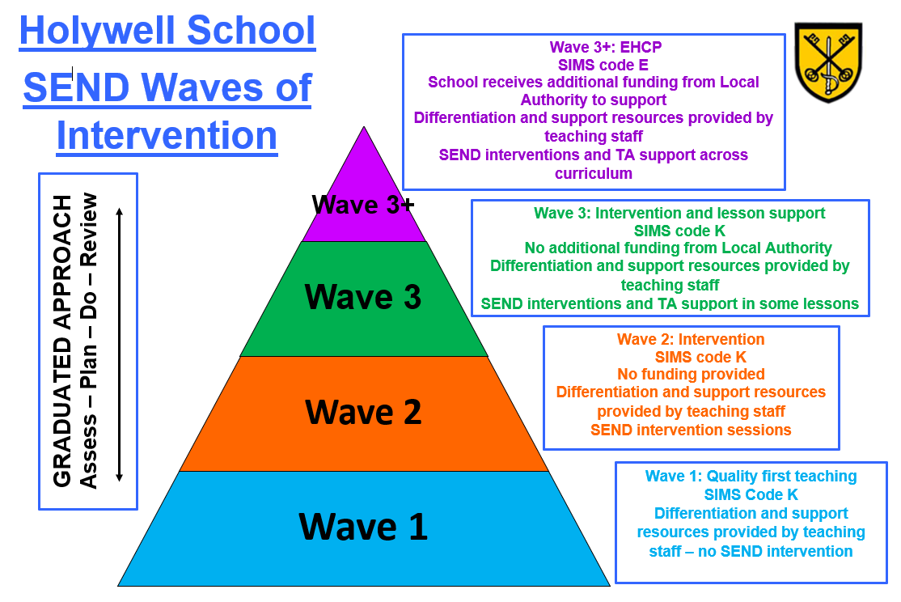

Once a need has been identified, students will be given a Wave of Intervention. This is decided by the Special Educational Needs and Disability Coordinator (SENDCo), in collaboration with staff, students and parents/carers. This outlines the level of support that the individual receives.

All children within our care will have access to quality first teaching provided by each and every member of staff. All teachers are responsible and accountable for the progress and development of the students in their class/classes, including where students access support from teaching assistants or specialist staff.

High quality teaching, differentiated for individuals and groups of students, is the first step in responding to students who have or may have special educational needs. Additional intervention and support cannot compensate for a lack of good quality teaching.

High quality teaching is promoted in our schools through appraisal procedures, which include:

* learning walks;
* lesson observations;
* work scrutiny;
* structured conversations with staff;
* training and Continuing Professional Development (CPD) opportunities;
* student progress meetings.

The school has systems in place for regular opportunities to observe, assess and record the progress of **all** children; this system is then used to identify children who may have additional needs.

This system includes reference to information provided by:

* regular and frequent data analysis;
* baseline assessment results;
* progress measured against the objectives in the National Curriculum;
* national curriculum descriptors for the end of a key stage;
* standardised screening and assessment tools;
* observations of behavioural, emotional and social development;
* an existing Education Health and Care Plan;
* assessments by a specialist service, such as educational psychology, identifying additional needs;
* another school or Local Authority (LA) which has identified or has provided for additional needs;
* information provided by parents, carers and the student;
* information provided by teachers and departments.

Based on the School’s observations and assessment data and following a discussion between the relevant staff members, SENDCo, parents/carers and students, children may be recorded as needing either additional support or learning opportunities. These children and young people are recorded as having SEND Support on the school information system (SIMS).

The school takes steps to apply the *Assess-Plan-Do-Review* cycle as indicated in the Code of Practice 2015 section 6:45 to 6:56. The school will use a variety of assessment and organisational tools, conversations with teachers, support staff, parents/carers and learners to carry out the process effectively. If through the *Assess-Plan-Do-Review* cycle, it is found that the child or young person has not made adequate progress, then additional measures will be put in place. Referrals can be made to specialist external agencies and professionals for further assessment and advice. All members of staff and parents/carers can raise their concerns to the SENDCo, who will then decide how to proceed.

If adequate support has been put in place over a prolonged period of time without any success and the student is performing significantly below age expected levels, then an application for an Education, Health and Care Needs Assessment may be made to the local Authority. In considering whether an Education, Health and Care Needs Assessment is necessary, the local authority will consider whether there is evidence that despite the school having taken relevant and purposeful action to identify, assess and meet the special educational needs of the child or young person, they have not made expected progress.

***Assess***

The SENDCo, Assistant SENDCo and relevant teaching staff will establish a clear analysis of the student’s needs over the course of the first half term. This will draw on teacher assessments and experience of the student, as well as information from the school’s own assessment systems for tracking student progress and attainment. It will also draw on the individual’s development in comparison to their peers, the views of the child and parents/carers. Liaison with external support services will take place as appropriate and observations will be carried out if needed.

***Plan***

Where possible, the views of the child and parents/carers will be obtained, usually at a meeting with the SENDCo and other relevant staff members. A one-page profile will be created, outlining areas of difficulty and strategies the staff can use to support these needs in lessons. All teachers and support staff who work with the student will be made aware of the needs and the strategies being put in place to support these.

***Do***

The form tutor and subject teachers, with support from the SENDCo, will remain responsible for the implementation of the one-page profile targets and monitoring the impact of interventions. The support and interventions provided will be delivered by appropriate members of staff and will have evidence of reliable outcomes.

***Review***

One-page profiles will be reviewed at points within the academic year, with the impact of support and interventions monitored. The SENDCo, with the support of teaching staff and form tutors, will revise the support in light of the student’s progress and development, deciding on any changes to support and revised outcomes. Student and parent/carer views will inform the review process and adaptations will be made depending on the success of the intervention. If the relevant progress has been made, the student may not need this intervention to continue.

If the child or young person has reached their desired outcomes they will no longer be documented on the school system as having SEND Support.

**Key staff in the department**

| **Staff member** | **Job Role** | **Relevant Qualification** |
| --- | --- | --- |
| Amanda Stepney | SENDCo |  |
| Claire Morison | Assistant SENDCo |  |
| [Emily Constable](mailto:econstable@holywellschool.co.uk) | Teaching Assistant |  |
| Claire Ellis | Teaching Assistant |  |
| Louise French | Teaching Assistant |  |
| Sarah Harlow | Teaching Assistant |  |
| Jamiee Hay | Teaching Assistant |  |
| [Maia Kotur](mailto:mkotur@holywellschool.co.uk) (maternity leave) | Teaching Assistant |  |
| [James Loose](mailto:jloose@holywellschool.co.uk) | Teaching Assistant |  |
| Tracy Richardson | Teaching Assistant (Part Time) |  |
| Shelley Sillett | Teaching Assistant (Part Time) |  |
| Tim Wyatt | Teaching Assistant |  |

The SEND Department has continued to grow this year and the passionate, enthusiastic and skilled workforce have once again strived to deliver a high-quality provision for our students in and out of lessons. There are a number of students on the SEND register who receive TA support through interventions or group sessions. TA support is monitored throughout the year and adjustments are made to the provision given on a month by month basis. If students are identified as needing further help, the team will adapt to accommodate this. Our SEND students at Holywell are supported in a variety of different ways. These include -

| 1-1 support in lessons | This provision is for all students on an EHCP (education, health and care plan). Students with an EHCP have an allocated amount of funding that will cover the hours they are required to be supported. The school must offer a further 12 hours a week of support.  Although TAs are in a lesson with the identified EHCP student, we promote some level of independence and so the TA will also offer support to other students who need additional support. In lessons, TAs will be expected to –   * Differentiate instructions given to students by subject teacher; * Ensure students have a firm understanding of what is expected of them before moving away; * Assist students with recording their ideas or planning pieces of work; * Adapt a question/task to suit the needs of the individual. |
| --- | --- |
| General support in lessons | The TA may be timetabled to support a lesson that has a number of students who need additional support. They will support by working with small groups/ moving around a number of individuals. Again, independent learning is encouraged. |
| Toe-by-Toe | Phonics-based reading programme that focuses on letter sounds and blending. Used for students with an extremely weak reading ability or students with dyslexia. The scheme has the biggest impact if completed every day. Students have access to 10 minutes sessions with TAs - these are mainly held in English lessons or registration periods. |
| Reading groups | TA-led sessions with small groups of children. TAs will listen to students reading aloud and will then go through some questions to help with comprehension. Intervention aimed at weaker readers so they benefit from sounding words out loud. |
| Homework Support Club | Three support sessions are run throughout the week to assist students with additional needs to access their homework tasks. This may include breaking the task into more manageable chunks or helping students who struggle to complete homework tasks at home. |

| Emotional Literacy Groups | Several small group sessions are run to help students improve their social skills. Children come together to complete a range of tasks, with emphasis on interacting appropriately in a number of social situations. |
| --- | --- |
| Lunchtime Provision | Every lunchtime from 1:05-2:10 we offer students a place to go to relax and enjoy quiet activities with their friends. This is for students with additional needs, offering them a place to go if the playground becomes too much. |

All interventions are monitored through our tracking document and success reviewed at several points throughout the year.

**Consulting with students and parents****/carers**

The school recognises the importance of the role of parents and carers and aims to work in partnership with students and parents/carers. In working with parents/carers the school aims to:

* acknowledge and draw on their knowledge and expertise in relation to the child;
* foster good lines of communication, including enabling them to feel confident in raising concerns they may have about the child’s learning or provision;
* focus on the child's strengths as well as areas of additional need;
* recognise the personal and emotional investment of parents/carers and be aware of their feelings;
* ensure that procedures are clear and that they are aware of how to access support in preparing their contributions, and are given documents to be discussed well before meetings;
* respect the validity of differing perspectives and seek constructive ways of reconciling different viewpoints;
* respect the differing needs parents/carers themselves may have, for example a disability or communication or linguistic barriers;
* recognise the need for flexibility in the timing and structure of meetings.

The SENDCo attends all parents’ evenings and is available for appointments on these dates to discuss queries or speak about progress made. Additional appointments can also be made over the course of the year if required.

**Involving additional** **agencies**

The support of the following external agencies is available to the school:

* Educational Psychology Service - they are providing assistance with students with EHCPs only at the moment
* Service for Sensory Impairment and Communication Difficulties
* SALT - Speech and Language Team
* School Nurse
* Education Welfare Officers (EWO)
* Child and Adolescent Mental Health Service (CAMHs)
* CHUMs
* Visual Impairment Team
* Hearing Impairment Team
* Jigsaw
* ASD Advisory Team, Ivel Valley
* Central Bedfordshire SEND Advisory Teacher

The SENDCo may contact these agencies for additional support in school, but will discuss with parents/carers before-hand.

**Transition support**

Our partner Lower Schoolsare a supportive and welcome contact. Liaison takes place via the Head, Deputy Head, Heads of Year and the SENDCo/Assistant SENDCo. An induction programme for Year Four students coming to School operates in order to establish a welcoming environment. The SENDCo attends the last review in the Lower School for students with an EHC Plan when this is possible. Additional meetings are set up so that the SENDCo or Assistant SENDCo can visit the Lower School to see the child in an environment that is familiar to them.

Liaison takes place with the Upper School via the Head, The Deputy Head, Head of Year, and the SENDCo/Assistant SENDCo. The procedure for the passing on of SEND information is well established. Regular meetings are held throughout the year between the SENDCo’s to ensure up to date procedures are shared and transition arrangements are in place well in advance of the move to Upper School.

Liaison with schools in our phase takes place via the SENDCos who are involved in extensive two-way information sharing to ensure adequate information is available regarding any individual student and their particular needs.

**Adaptations to the curriculum and learning environment**

Teaching staff are committed to working tirelessly to ensure all students are included in the educational journey in lessons. This is done in a variety of ways –

* regular communication with SENDCo and team to ensure that individual needs are being met;
* awareness of all students with additional needs and disabilities and how to best support them in lessons;
* attendance at SENDCo led sharing good practice sessions, which enable them to keep up to date with strategies to be used in lessons to support;
* differentiation of in-lesson tasks and support materials;
* effective deployment of teaching assistants within the lesson to support individual’s needs;
* regular contact with SENDCo to discuss student success and areas of concern;
* use of specialist equipment to suit the student’s needs.

The learning environment is reviewed when necessary – if additional needs arise, the environment will be assessed accordingly. We are able to put provision in place for a variety of needs and feel that the school grounds are accessible to all.

**Evaluating effectiveness**

The SEND department strives to ensure that the provision that is being put in place is effective and impactful. There are several ways in which this is done –

* a SEND department audit is carried out as part of the self-evaluation process. This in-depth document enables the SENDCo to identify department successes but to also look at areas for further development;
* a SEND department self-evaluation form is completed in liaison with the SEND Advisory Teacher at the start of each academic year to further highlight areas for development to focus on for the following year;
* learning walks are conducted throughout the year to observe good practice in a variety of lessons;
* performance management meetings are conducted at the beginning of each academic year to measure individual progress made by members of the department and to recognise areas they wish to focus on for the coming year;

The department welcomes feedback from parents and carers and will consider suggestions made for improvement where possible.

**Handling complaints**

For SEND concerns or complaints, the whole-school Complaints Procedure should be used (cf: Complaints Policy).

Additional support can be provided by Central Bedfordshire’s SENDIASS support service. SENDIASS is a free, confidential and impartial support service for parents / carers of children and young people with special educational needs and disabilities (SEND). It supports children and young people from 0 to 25 in an educational setting.

Telephone: 0300 300 8088 – 9am to 3pm, Monday to Friday

Email: sendiass@centralbedfordshire.gov.uk

Issues regarding an EHCP will be raised at the EHCP review.

**Local Offer**

For further information on the Local Offer and services that are offered across the local authority, please follow the links below –

***Bedford Borough –*** www.sendguide.bedford.gov.uk

***Central Bedfordshire - https://localoffer.centralbedfordshire.gov.uk/kb5/centralbedfordshire/directory/home.page***

**Named contacts**

For further information or advice relating to this report or any related matters, please contact the SENDCo directly. If your query or issue is relating to another issue, please use the contact details listed below -

| Name of individual | Email address | Phone number |
| --- | --- | --- |
| Amanda Stepney | astepney@holywellschool.co.uk | 01234 750381 |
| Claire Morison | cmorison@holywellschool.co.uk | 01234 750381 |
| Central Bedfordshire SEND Support Team | cbcsendpypps@centralbedfordshire.gov.uk | 03003008356 |
| Bedford Borough SEND Support Team | sendteam@bedford.gov.uk | 01234 228375 |